Project Summary Information
  - Date: 06 September 2017
Contracting Agency: | European Defence Agency (EDA)
Contract Number | 16.CAT.OP.131
Project Duration | 01 Dec. 2016 - 07 Feb. 2018
Contact: | Jose Luis Delgado Gamella  (email: jldelgado@gmv.com)
Companies Involved: | TNO (The Netherlands)  Larimart S.p.A (Italy)  Rheinmetall Electronics GmbH (Germany)  GMV (Spain)

Background
The study STASS II shall define an open Standard Architecture for Soldier Systems. Therefore it shall comply with the following:
- Open standards
- Interoperable
- Interchangeable
- Portable
- Modular
- Scalable
The STASS I study was focused on the power aspects of the Dismounted Soldier System (DSS). It proposed a Reference Power Architecture for Soldier Systems which should be used to derive the target power architecture for a specific system to be procured or built by EU Member States participating in the activities of the European Defence Agency. However, and since power and data cannot be easily separated, the STASS I study recommended to define a complete Soldier System Reference Architecture also covering electronics and data before standardisation.
The STASS II study shall focus on data management and infrastructure, which covers electronics, voice and data communications, software, human interface devices and sensors. Furthermore, it shall meet the following substantial requirements.

Operational Effectiveness
The study will be comprehensive in the sense of integrating not only the architectural description of data management/infrastructure but also that of power, previously studied in the project STASS I, in an on-the-man architecture. It will be taken into consideration the relationship of power and data subsystems, not only by sharing some hardware but also in the sense of variable configuration of subsystems depending on existing energy levels. The architecture will only consider Open Standards and technologies, avoiding the positioning in favour of any proprietary standard or technique.
The study will provide a modular approach that not only considers the needs of the isolated dismounted soldier but those of different soldier roles in a small unit to which the soldier belongs, such as Fire Teams and Squad, attending the needs of different scenarios.

Complementary with STASS I
The design of the STASS II shall focus on the data management and infrastructure which covers electronics, voice and data communications, software, human interface devices and sensors. Since STASS I study already developed a standard architecture for soldier systems with focus on power, it shall be taken into account in the STASS II study in order to develop a comprehensive reference open architecture for soldier systems. All views developed under the STASS I shall be reused to the maximum extent possible and shall not be duplicated.
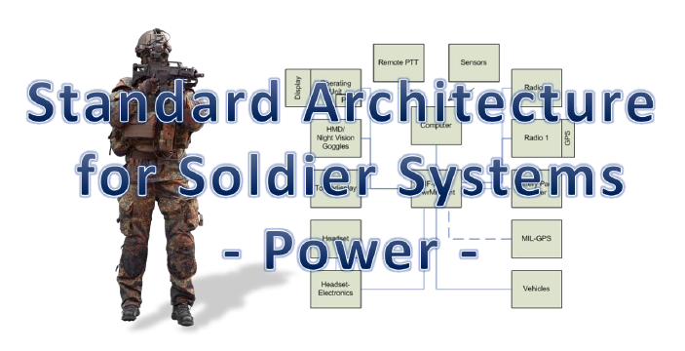

Standardisation and harmonisation
The STASS II shall ensure that the architecture and infrastructure are applicable to current and future systems. It shall provide interfaces that comply with publicly available open standards which are already established or under preparation.
It shall consider international operations by evaluating possibilities for interoperability and interchangeability. Therefore, special emphasis shall be given to the definition of interfaces with all necessary layers including connectors, voltages, data protocols and data models, etc. preferably based on existing or upcoming standards. Existing gaps need to be identified and proposals for solutions developed.
The design of the STASS shall foster harmonization. It shall be based on a harmonized on-the-man general concept of open power architecture for soldier systems covering the aspects described below. It shall allow for a modular approach to support different soldier’s equipment configurations as required by participating member states. This general concept shall be supported by the development of operational, system and technical architectural views.
There are currently several soldiers’ equipment programmes running in Europe, such as FELIN (FR), IDZ-ES (DE), Soldato Futuro (IT), TITAN (PL), COMFUT (ES), VOSS-SmartVest (NLD) and FIST (UK). Most of them are still in a prototyping and field test stage and can thus still be influenced. These programmes resulted in a broad range of very different approaches which grew out of the individual national developments and are only loosely synchronised between the nations. As there are a few nations which already fielded their soldier system, their approaches and lessons learned should be considered on a European level as well as in the other nations.
The design of the STASS II shall also be geared towards standardisation. It shall thus be based on a harmonized concept, which must be supported by a roadmap to establish a standard based on it. Open architectures have been used for standardizing the individual aspects of systems in order to guide component developers. These require much lower integration efforts while, at the same time, increase component production numbers. At present, all standardization options are possible, including via national mechanisms, NATO or the European Standardization Organization.
However, since all participating member states partaking in the Capability Technology (CapTech) Ground Systems activities are heavily involved in the NATO Dismounted Soldier Systems work, synchronization and complementarity with NATO standardization activities should be sought. Therefore, existing standardisation activities, such as UK Generic Soldier Architecture, NATO STANAGs and others, as applicable, shall be analysed and taken into account for the design of the STASS II. A cost-benefit analysis for the development and the implementation of such a standard shall be conducted.
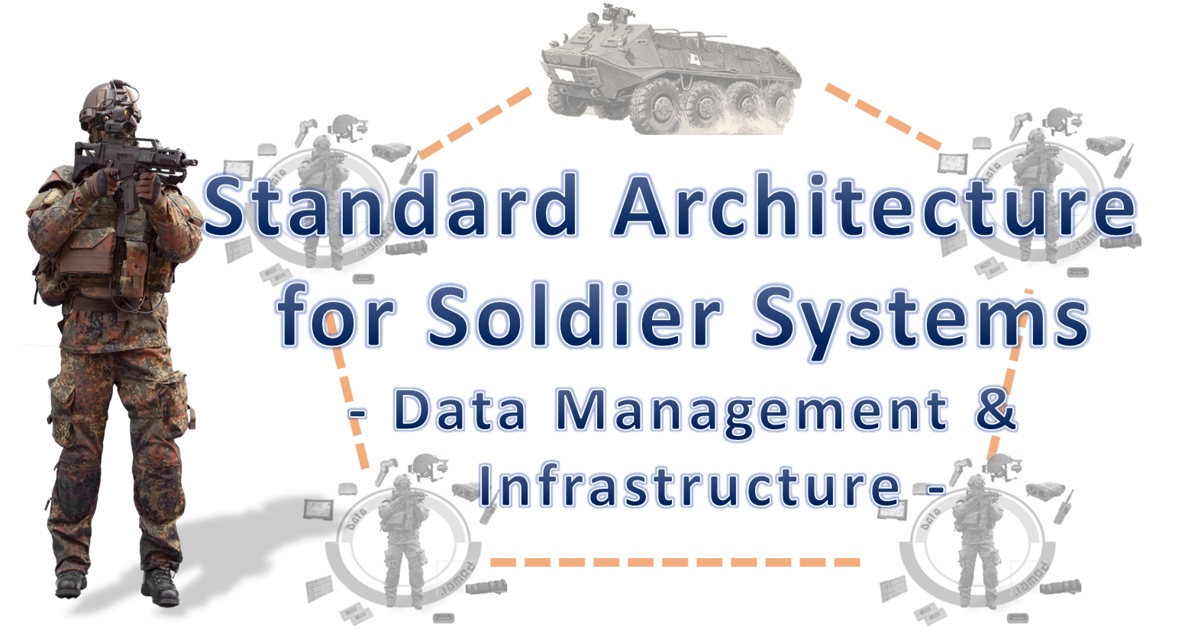

Technological innovation
The STASS II shall ensure that the architecture and infrastructure are not only applicable to current systems, referred to above, but also future systems.
The following aspects of such future soldier system shall be taken into account when developing architectural views for data management and infrastructure:
- body sensors to monitor health and physical fitness like soldier’s hydration, heart rate, temperature, body movement and other biometric indicators,
- future systems to provide capability with augmented reality with variety of tasks ranging from blue-force tracking, GPS navigation to soldier co-ordination and target designation,
- night vision devices,
- dissemination of information collected or acquired by soldiers sensors or devices to other members of the deployed squad (team) via different communication means like tactical communications radios, Bluetooth or Wi-Fi connectivity,
- ability to operate C4ISTAR technology while maintaining eyes on target,
- ability to provide essential navigation information by audio as well, like in a homing service,
- integration of technologies enabling the following capabilities:
  - position location information (e.g. GPS or technologies which can provide GPS equivalent information in a denied environment like inertial navigation technology or vision-generated data)
  - scalable, mobile and over the horizon communication network
  - mobile ad hoc networks (MANETs)
  - data moving software defined radio waveforms
  - high-bandwidth information/data management
  - command-control systems (C2)
  - all source fusion and distribution of data
  - information management
  - open standard airborne ISR transport modems
  - auxiliary power technologies
  - small high power sources
  - high resolution, 3D and multicolour electro-optical
  - multiple moving target tracking for unmanned and manned ISR platforms

Approach
All work packages will be carried out iteratively (STASS II Design Document v1, v2, and v3) providing more and more mature and comprehensive views.

WP0 “Project Management and Overall Coordination” (lead: GMV)
WP0 manages and coordinates the study and ensures the timely delivery of the results. It organizes the engagement with the stakeholders.

WP1 “Definition of Common European Capabilities, Scenarios, and Requirements” (lead: RDE)
In WP1, the NATO Capability Views and the NATO Operational Views are developed. Also a few typical scenarios or vignettes are formulated and functional (NATO Service-Oriented Views) and non-functional requirements are harmonized.
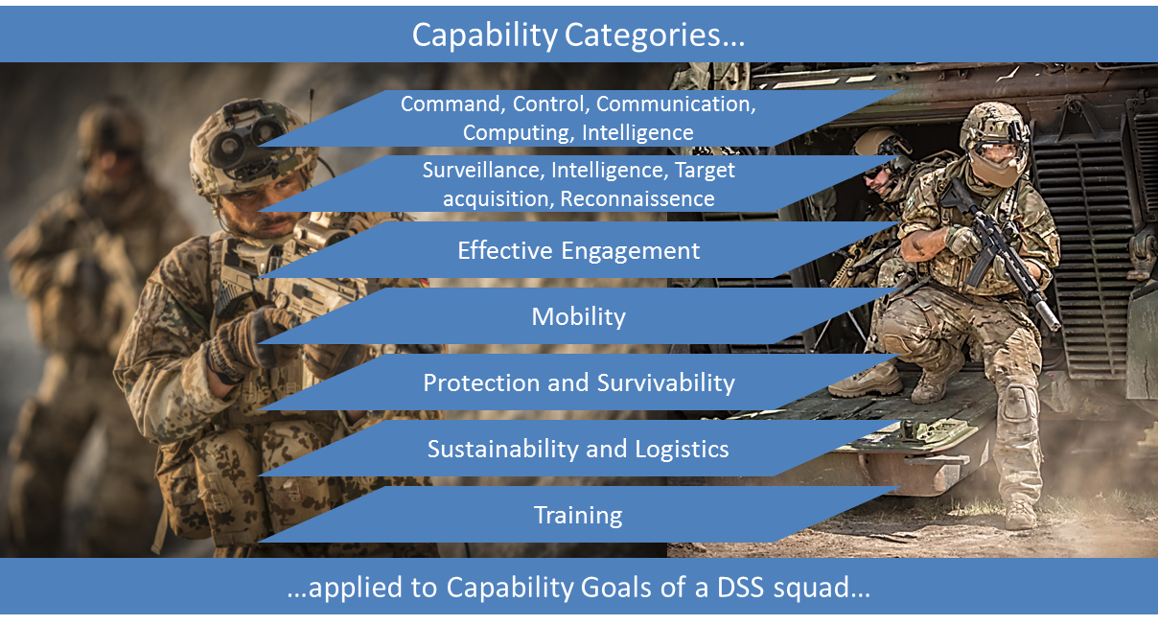

WP2 “Analysis of current soldier systems and identification of standardisation technology potentials with focus on data management and infrastructure” (lead: Larimart)
The information available for the study of the current soldier systems will be analysed. Especially the German IdZ-ES, the Spanish COMFUT, the Dutch VOSS-SmartVest, and the Italian Soldato Futuro are considered as study team members are directly involved with their development. Other national programs are addressed through e.g. involvement in NATO Working Groups. Architectural aspects and potential standards / technologies are harmonized. WP2 will produce a draft NATO System Views derived from existing systems.

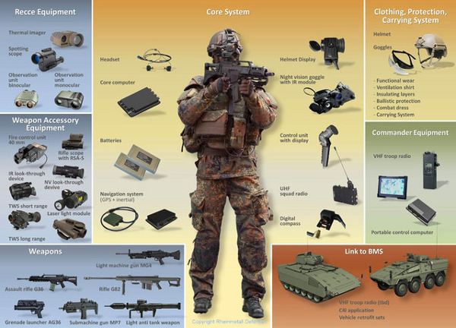

WP3 “Identification and analysis of standards” (lead: TNO)
WP3 analyses the current state of technology, possible future developments and relevant activities and programs. It also identifies relevant standards and technologies which results in the NATO Technical Views, as well as technology and standards gaps that need to be covered in the future.

WP4 “Development of Dismounted Soldier System View” (lead: GMV)
WP4 will refine the draft NATO System Views (considering output of WP1, WP2, and WP3) including the mapping of standards and technologies onto the views.

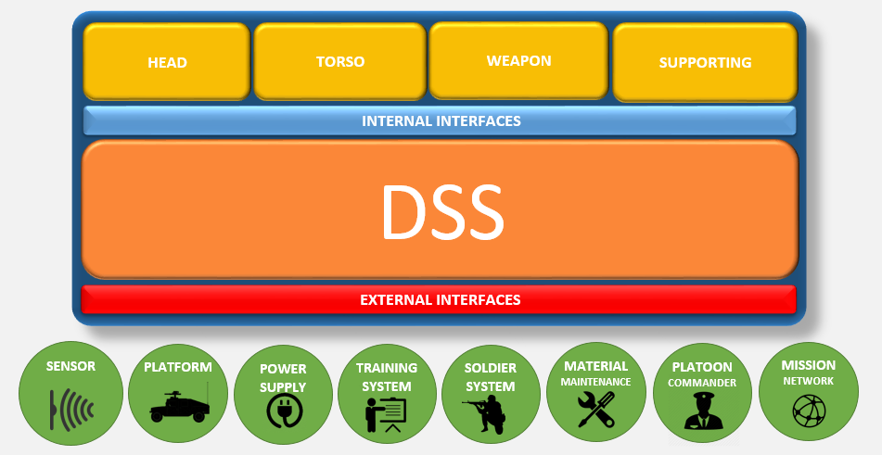

WP5 “Cost benefit estimation and Roadmap” (lead: RDE)
WP5 carries out a cost benefit analysis and focus on a concrete planning of technical activities to achieve a technically stable system architecture for a future soldier system with regard to data management aspects.

WP6 “Integration of Deliverables, Recommendations, and Executive Summary” (lead: GMV)
WP6 formulates the publishable Executive Summary, integrates deliverables and makes recommendations obtained from the results of the study.

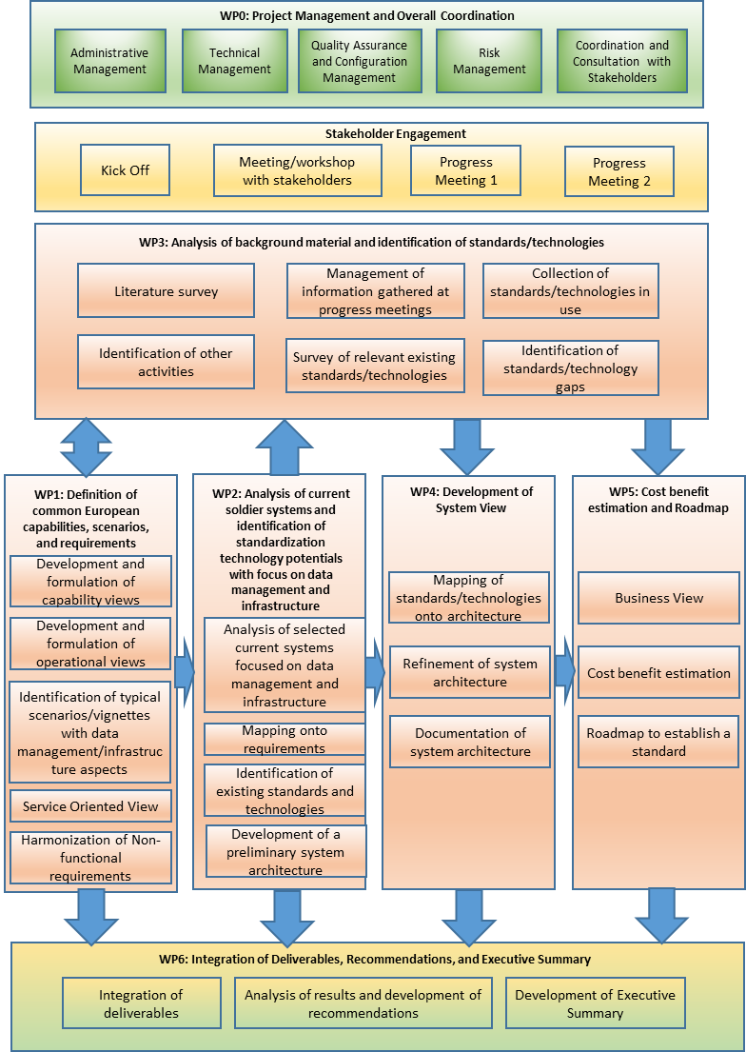
Study logic

