ANNEXES

PROPOSAL SUBMISSION FORM & CHECKLIST OF DOCUMENTS TO BE SUBMITTED
“EDA Research, Technology and Innovation Papers Award 2023”
INNOVATIVE TECHNOLOGIES, PROCESSES AND APPLICATIONS FOR ENHANCED FUTURE DEFENCE CAPABILITIES
23.RTI.PRZ.136
- SUBMITTED by (i.e. the identity of the Applicant)
 | Name(s) of legal entity or entities submitting this application. | Nationality
Lead participant
Participant 2
Etc …
- CONTACT PERSON for this application (to act as focal point for all communication which may take place between EDA and the Applicant)
Name and position
Organisation
Address
Telephone
e-mail

Signed on behalf of the Applicant:

Name
Signature
Date

Checklist of documents to be submitted
The purpose of the table below is to facilitate the preparation of the application by providing an overview of the documents that shall be included (marked by ) depending on the role of each participant in the application (lead participant in joint application, participant in joint application, single participant).
Description | Lead participant | All participants in joint application | Single Participant
Application submission form
¹ Legal Entity Form

Supporting documents for the Legal Entity File Form

² Financial Identification form (either signed & stamped by the bank or accompanied by a recent bank statement)

Exclusion Criteria form
Paper Template

The Legal Entity Form is to be signed by all applicants. A standard template in each EU language is available at: http://ec.europa.eu/budget/contracts_grants/info_contracts/legal_entities/legal_entities_ en.cfm
2 The Financial identification form shall be duly filled in and signed by the applicant and his or her banker (or to be accompanied by a recent bank statement). The form is available at the following Internet address: http://ec.europa.eu/budget/contracts_grants/info_contracts/financial_id/financial_id_fr.cfm

EXCLUSION CRITERIA FORM (23.RTI.PRZ.136)
Declaration on honour on
exclusion criteria

The undersigned [insert name of the signatory of this form], representing:
(only for natural persons) himself or herself | (only for legal persons) the following legal person:
ID or passport number:  (‘the person’) | Full official name:  Official legal form:  Statutory registration number:  Full official address:  VAT registration number:  (‘the person’)

I – Situation of exclusion concerning the person
- declares that the above-mentioned person is in one of the following situations: | YES | NO
- it is bankrupt, subject to insolvency or winding up procedures, its assets are being administered by a liquidator or by a court, it is in an arrangement with creditors, its business activities are suspended or it is in any analogous situation arising from a similar procedure provided for under national legislation or regulations;
- it has been established by a final judgement or a final administrative decision that the person is in breach of its obligations relating to the payment of taxes or social security contributions in accordance with the law of the country in which it is established, with those of the country in which the contracting authority is located or those of the country of the performance of the contract;
- it has been established by a final judgement or a final administrative decision that the person is guilty of grave professional misconduct by having violated applicable laws or regulations or ethical standards of the profession to which the person belongs, or by having engaged in any wrongful conduct which has an impact on its professional credibity where such conduct denotes wrongful intent or gross negligence, including, in particular, any of the following:
(i) fraudulently or negligently misrepresenting information required for the verification of the absence of grounds for exclusion or the fulfilment of selection criteria or in the performance of a contract;
(ii) entering into agreement with other persons with the aim of distorting competition;
(iii) violating intellectual property rights;
(iv) attempting to influence the decision-making process of the contracting authority during the award procedure;

(v) attempting to obtain confidential information that may confer upon it undue advantages in the award procedure;
- it has been established by a final judgement that the person is guilty of the following:
(i) fraud, within the meaning of Article 1 of the Convention on the protection of the European Communities' financial interests, drawn up by the Council Act of 26 July 1995;
(ii) corruption, as defined in Article 3 of the Convention on the fight against corruption involving officials of the European Communities or officials of EU Member States, drawn up by the Council Act of 26 May 1997, and in Article 2(1) of Council Framework Decision 2003/568/JHA, as well as corruption as defined in the legal provisions of the country where the contracting authority is located, the country in which the person is established or the country of the performance of the contract;
(iii) participation in a criminal organisation, as defined in Article 2 of Council Framework Decision 2008/841/JHA;
(iv) money laundering or terrorist financing, as defined in Article 1 of Directive 2005/60/EC of the European Parliament and of the Council;
(v) terrorist-related offences or offences linked to terrorist activities, as defined in Articles 1 and 3 of Council Framework Decision 2002/475/JHA, respectively, or inciting, aiding, abetting or attempting to commit such offences, as referred to in Article 4 of that Decision;
(vi) child labour or other forms of trafficking in human beings as defined in Article 2 of Directive 2011/36/EU of the European Parliament and of the Council;
- the person has shown significant deficiencies in complying with the main obligations in the performance of a contract financed by the Union’s budget, which has led to its early termination or to the application of liquidated damages or other contractual penalties, or which has been discovered following checks, audits or investigations by an Authorising Officer, OLAF or the Court of Auditors;
- it has been established by a final judgment or final administrative decision that the person has committed an irregularity within the meaning of Article 1(2) of Council Regulation (EC, Euratom) No 2988/95;

- for the situations of grave professional misconduct, fraud, corruption, other criminal offences, significant deficiencies in the performance of the contract or irregularity, the applicant is subject to:
- facts established in the context of audits or investigations carried out by the Court of Auditors, OLAF or internal audit, or any other check, audit or control performed under the responsibility of an authorising officer of an EU institution, of a European office or of an EU agency or body;
- non-final administrative decisions which may include disciplinary measures taken by the competent supervisory body responsible for the verification of the application of standards of professional ethics;
- decisions of the ECB, the EIB, the European Investment Fund or international organisations;
- decisions of the Commission relating to the infringement of the Union's competition rules or of a national competent authority relating to the infringement of Union or national competition law; or
- decisions of exclusion by an authorising officer of an EU institution, of a European office or of an EU agency or body.

II – Situations of exclusion concerning natural persons with power of representation, decision-making or control over the legal person
Not applicable to natural persons, Member States and local authorities
- declares that a natural person who is a member of the administrative, management or supervisory body of the above-mentioned legal person, or who has powers of representation, decision or control with regard to the above-mentioned legal person (this covers company directors, members of management or supervisory bodies, and cases where one natural person holds a majority of shares) is in one of the following situations: | YES | NO | N/A
Situation (c) above (grave professional misconduct)
Situation (d) above (fraud, corruption or other criminal offence)
Situation (e) above (significant deficiencies in performance of a contract)
Situation (f) above (irregularity)

III – Situations of exclusion concerning natural or legal persons assuming unlimited liability for the debts of the legal person
- declares that a natural or legal person that assumes unlimited liability for the debts of the above-mentioned legal person is in one of the following situations: | YES | NO | N/A

Situation (a) above (bankruptcy)
Situation (b) above (breach in payment of taxes or social security contributions)

IV – Grounds for rejection from this procedure
- declares that the above-mentioned person: | YES | NO
- has distorted competition by being previously involved in the preparation of procurement documents for this procurement procedure.
- has already received any other Union prize that is the subject of the current contest cannot receive a second prize for the same activities.

V – Remedial measures
If the person declares one of the situations of exclusion listed above, it must indicate measures it has taken to remedy the exclusion situation, thus demonstrating its reliability. This may include e.g. technical, organisational and personnel measures to prevent further occurrence, compensation of damage or payment of fines. The relevant documentary evidence which illustrates the remedial measures taken must be provided in annex to this declaration. This does not apply for situations referred in point (d) of this declaration.

VII – Evidence for selection
The signatory declares that the above-mentioned person is able to provide the necessary supporting documents listed in the relevant sections of the rules of contest and which are not available electronically upon request and without delay.
The above-mentioned person may be subject to rejection from this procedure and to administrative sanctions (exclusion or financial penalty) if any of the declarations or information provided as a condition for participating in this procedure prove to be false.

Full name Date Signature

REIMBURSEMENT OF EXPENSES (WINNING APPLICATION)
In line with section 1.3 of the Rules of Contest “EDA will cover the travel expenses and accommodation, for the winners to attend the award ceremony for an amount of up to 1 000 € per representative (3 000 € in total)’’. The following conditions will apply:

- The contracting authority reimburses travel and subsistence expenses on the basis of the shortest itinerary and the minimum number of nights necessary for overnight stay at the destination.
- The contracting authority reimburses travel expenses as follows:
(a) travel by air: up to the maximum cost of an economy class ticket at the time of the reservation;
(b) travel by boat or rail: up to the maximum cost of a first-class ticket;
(c) travel by car: at the rate of one first class rail ticket for the same journey and on the same day;

In addition, the contracting authority reimburses travel outside Union territory if it has given its prior written approval for the expenses.

- The contracting authority reimburses subsistence expenses on the basis of a daily subsistence allowance as follows:

- for journeys of less than 200 km for a return trip, no subsistence allowance is payable;
- the daily subsistence allowance is payable only on receipt of supporting documents proving that the person concerned was present at the destination;
(c) the daily subsistence allowance takes the form of a flat rate payment to cover all subsistence expenses, including meals, local transport including transport to and from the airport or station, insurance and sundries;
(d) the daily subsistence allowance is reimbursed at the flat rate of 92 EUR;
(e) accommodation is reimbursed on receipt of supporting documents proving the necessary overnight stay at the destination, up to the flat rate ceilings of 140 EUR

TECHNICAL PROPOSAL TEMPLATE

Formatting Guides for Authors
INNOVATIVE TECHNOLOGIES, PROCESSES AND APPLICATIONS FOR ENHANCED FUTURE DEFENCE CAPABILITIES
Title

Full Name¹ and Full Name ²
¹Department of -, City, Country
other@xx.yy.zz
²Institution -, City, Country
other@zzz.com

Abstract

This paper gives complete guidelines for authors submitting papers for the EDA Papers Award.

Keywords

EDA Innovation, Research, Defence
1. Introduction

This document describes, and is written to conform to, author guidelines for the EDA Best Papers Award 2023. It is prepared in Microsoft Word as a .doc document. Although other means of preparation are acceptable, final, camera-ready versions must conform to this layout. Microsoft Word terminology is used where appropriate in this document. Although formatting instructions may often appear daunting, the simplest approach is to use this template and insert headings and text into it as appropriate.
2. Format Guide

The following formatting rules must be followed strictly. This (.doc) document may be used as a template for papers prepared using Microsoft Word. Papers not conforming to these requirements may not be published in the conference proceedings.
2.1. General Format, Page Layout and Margins

Standard A4 (210mm x 297mm) portrait page set-up should be used. The left, right, top and bottom margins should be 30mm. Do not use any headers, footers or footnotes. No page numbers. Single column. All main text paragraphs, including the abstract, must be fully (left and right) justified. All text, including title, authors, headings, captions and body, will be Times New Roman font.
2.2. Title

The title is to be written in 20 pt. Garamond font, centred and using the bold and “Small Caps” formats. There should be 24 pt. (paragraph) spacing after the last line.
2.3. Authors

Author names are to be written in 13 pt. Times New Roman format, centred and followed by a 12pt. paragraph spacing. If necessary, use superscripts to link individual authors with institutions as shown above. Author affiliations are to be written in 12 pt. Times New Roman, centred, with email addresses, in 10 pt. Courier New, on the line following. The last email address will have an 18 pt. (paragraph) spacing following.
2.4. Abstract

The Abstract section begins with the word, “Abstract” in 13 pt. Times New Roman, bold italics, “Small Caps” font with a 6pt. spacing following. The abstract must not exceed 150 words in length in 10 pt. Times New Roman italics. The text must be fully justified, with a 12 pt. paragraph spacing following the last line.
2.5. Keywords

The Keywords section begins with the word, “Keywords” in 13 pt. Times New Roman, bold italics, “Small Caps” font with a 6pt. spacing following. There may be up to five keywords (or short phrases) separated by commas and six spaces, in 10 pt. Times New Roman italics. An 18 pt. line spacing follows.
2.6. Section and sub-section headings
Section headings are numbered 1. Xxx, 2. Yyy, etc. in 14 pt. bold “Small Caps” Times New Roman font with a 6 pt. line spacing following.

Subsection headings are numbered 1.1. Aaa, 1.2. Bbb, etc. in 12 pt. bold Times New Roman font with a 6pt line spacing following.

2.6.1. Further Subsections

Further sub-sectioning, if required, is indicated using 1.1.1. Qqq, etc. headings with 11 pt. bold Times New Roman font with a 6pt line spacing following.
2.7. Text

Main-body text is to written in fully (left and right) justified 11 pt. Times New Roman font with a 6pt. (paragraph) line spacing following the last line of each paragraph, but a 12pt. (paragraph) line spacing following the last paragraph. Do not indent paragraphs.
2.8. Figures and Tables
Table 1. Heading and text fonts.
Text | Alingnment | Font | Followed by:
Title | Centre | 20 pt. TNR, bold, small-caps | 24 pt. line sp.
Authors | Centre | 13 pt. TNR | 12 pt. line sp.
Addresses | Centre | 12 pt. TNR
emails | Centre | 11 pt. italic TNR | 18 pt. line sp. (last)
Abstract heading | Left | 13 pt. bold italic TNR, small caps | 6 pt. line sp.
Abstract text | Left | 10 pt. italic TNR | 12 pt. line sp.
Keywords heading | Left | 13 pt. bold italic TNR, small caps | 6 pt. line sp.
Keywords | Left, left, .. | 10 pt. italic TNR | 18 pt line sp.
Section headings | Left | 14 pt. bold TNR, small caps | 6 pt. line sp.
Sub-section heads | Left | 12 pt. bold TNR | 6 pt. line sp.
Sub-sub-sections | Left | 11 pt. bold TNR | 6 pt. line sp.
Body text | Full (left/right) | 11 pt. TNR | 12 pt line sp. (last)
Figures | Centre |  | 6 pt. line sp.
Figure captions | Centre | 11 pt. TNR | 12 pt. line sp.
References | Left | 10 pt. TNR (as shown) | 6 pt. line sp

All inserts, figures, diagrams, photographs and tables must be centre-aligned, clear and appropriate for black/white or greyscale reproduction.
Figures (eg, Figure 1) must be numbered consecutively, 1, 2, etc., from start to finish of the paper, ignoring sections and subsections. Tables (eg, Table 1) are also numbered consecutively, 1, 2, etc., from start to finish of the paper, ignoring sections and subsections, and independently from figures
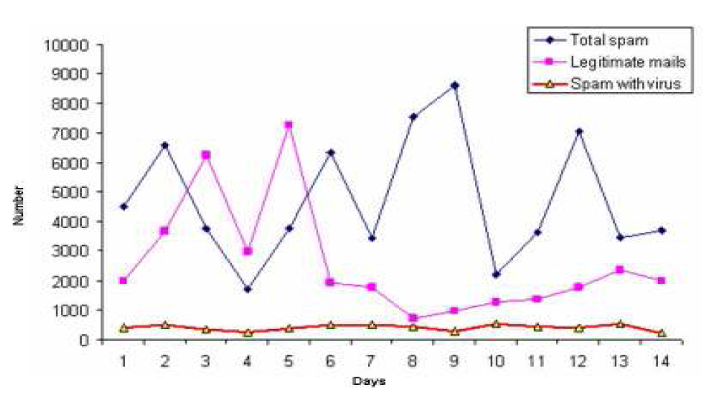
Figure 1. Spam traffic sample
All figures, tables, etc. must have a caption, centre-justified in 11 pt. Times New Roman. Captions precede tables but follow figures. Tables and figures must appear as close to their point of reference as satisfactory formatting of the final document permits.
2.9. Acknowledgements
An (unnumbered) acknowledgements section may be inserted if required.
2.10. References
References should be cited in the main text, in passing [1] or explicitly as in [2]. The full references should be given as below (essentially IEEE format), in the order in which they are cited, in 10 pt. Times New Roman, with a 6pt spacing between each.
3. Conclusions
Papers in this format must not exceed eight (8) pages in length, including references.
Acknowledgements
The authors would like to thank everyone. Good luck!

References
[1] Lee, S.hyun. & Kim Mi Na, (2008) “This is my paper”, ABC Transactions on ECE, Vol. 10, No. 5, pp120-122.

Authors
Photo

Short Biography

Country in which the legal entity is registered
If this application is being submitted by an individual legal entity, the name of the legal entity should be entered as “Lead participant” (and all other lines should be deleted)

