REGISTRATION FORM

CYPRUS MoD – EUROPEAN DEFENCE AGENCY Maritime Security Conference 12-13 November 2015
“The Challenges, Benefits and Opportunities
of the European Union Maritime Security Strategy”

Venue: Filoxenia Conference Center, Nicosia, Cyprus

Delegate information (please fill spaces using capital letters)
First name: |  |  | Family name:
Title: | Choose an item. |  | Rank: |  | Choose an item.
Position:
Name of PMs/Country |  |  | Choose from the list.
Name of Organisation/Agency/ Other:
Nationality: |  |  | Choose from the list.
Address :
City: |  |  | Post Code:
Country: |  |  | Choose from the list.
E-mail address:
Phone number: (Country code – phone number) |  |  | +
I will attend the cocktail reception on the 11th November 2015 |  |  | Choose an item.
I will stay in: |  |  | Choose an item.
Flights Details
Arrival |  | Date Click here to enter a date. |  | Flight Number:
Departure |  | Date Click here to enter a date. |  | Flight Number:
P.S Military officers are requested to wear uniform.
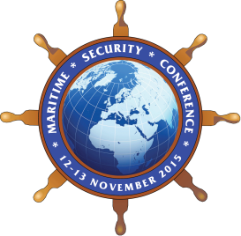 | To be returned via email to CYPRUS MOD  E-mail: seminar@mod.gov.cy  Tel: +357 22807671 or +357 22807654

